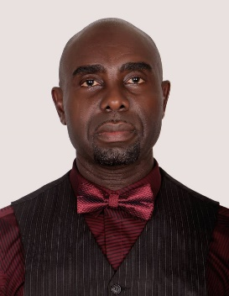
D. Matthias pursued B.Sc. in Mathematics/Computer Science at the University of Port Harcourt, Rivers State, Nigeria, M.Tech. from the Federal University of Technology Owerri, Nigeria and PhD from the Rivers State University of Science and Technology, Port Harcourt, Nigeria. He is currently appraised for Professor in the Department of Computer Science, Rivers State University formally Rivers State University of Science and Technology. He is a member of Computer Professional of Nigeria (CPN) since 2010 and a life member of Nigeria Computer Society (NCS) since 2012. He has many scholarly publications in reputed local and international journals. His main research work focuses on Scientific Computing and Database System, Software Development.

